
Hans Raj Mahila Maha Vidyalaya, Jalandhar
7.1.5

Green Campus Initiatives of the Institution
-Various Policy documents/decisions circulated for implementation

Various policy documents
Quality Policy
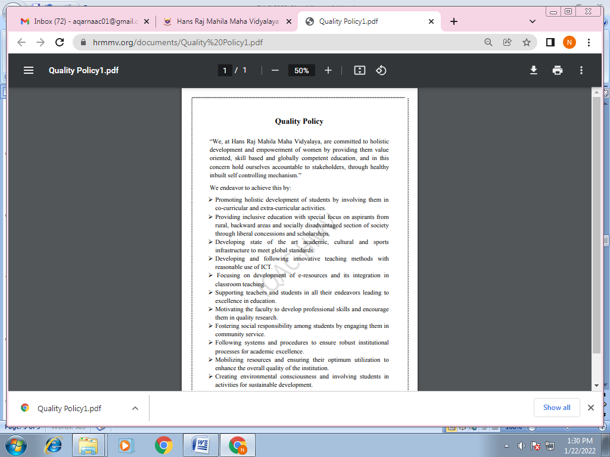
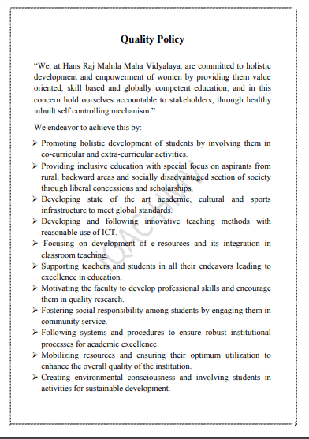
https://www.hrmmv.org/documents/Quality%20Policy1.pdf

Green Policy of the Institution
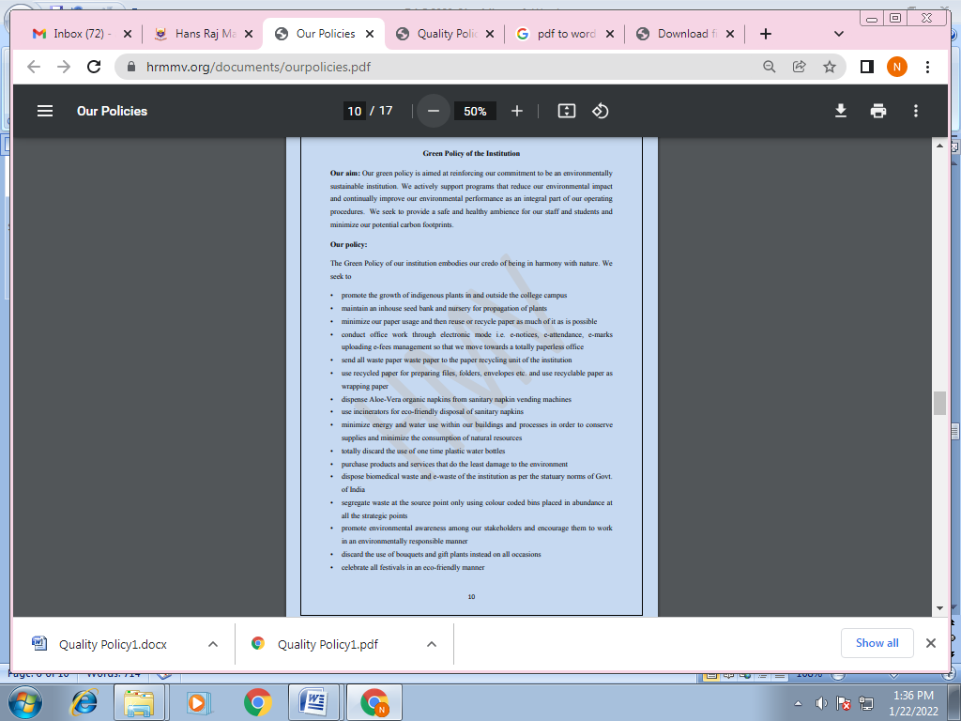
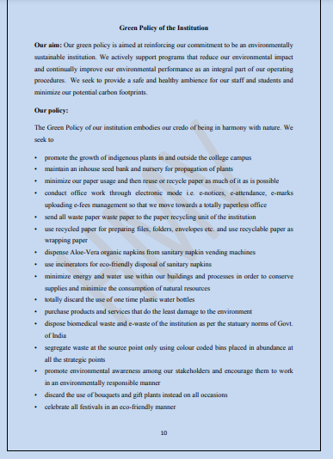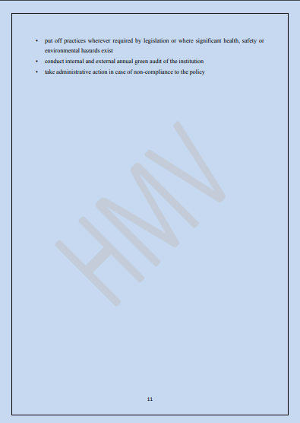
https://www.hrmmv.org/documents/ourpolicies.pdf (page 10-11)
Decisions circulated for implementation
- Circular regarding parking vehicles at designated places

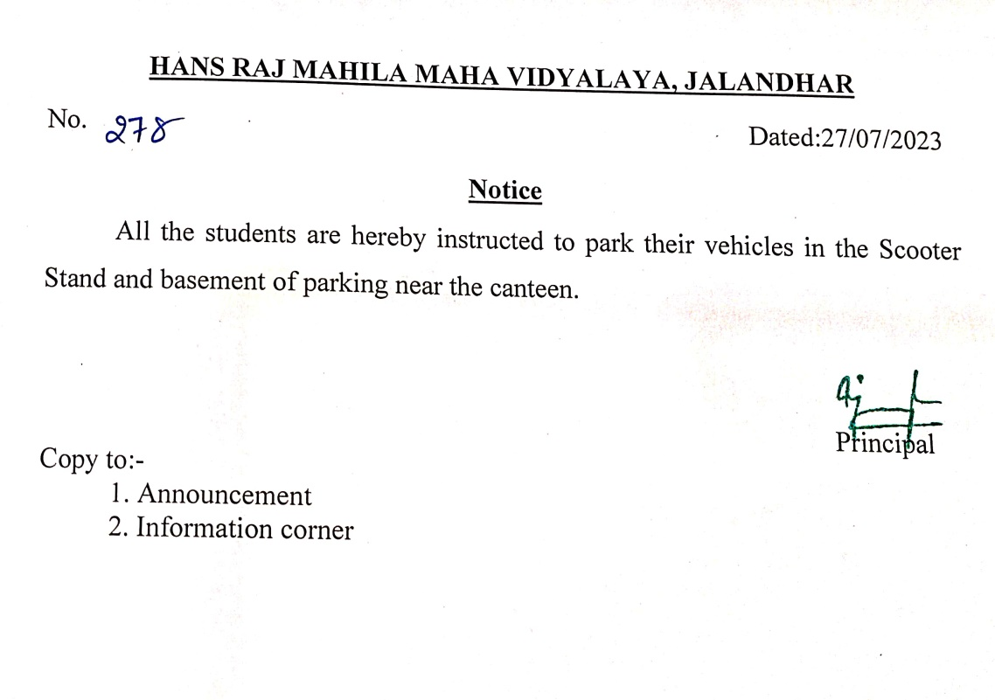

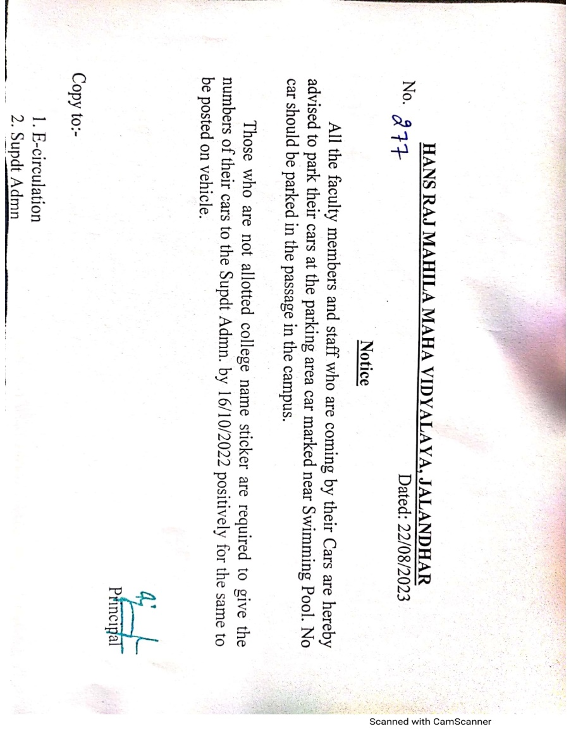

- Ban on the use of Plastics
